INSECTICIDES INDIA LTD.
CH21,GIDC INDI.ESTATE, DAHEJ-VAGRA,
BHARUCH(GUJARAT)
Distt. BHARUCH (GUJARAT)-392130
GUJARAT, INDIA.
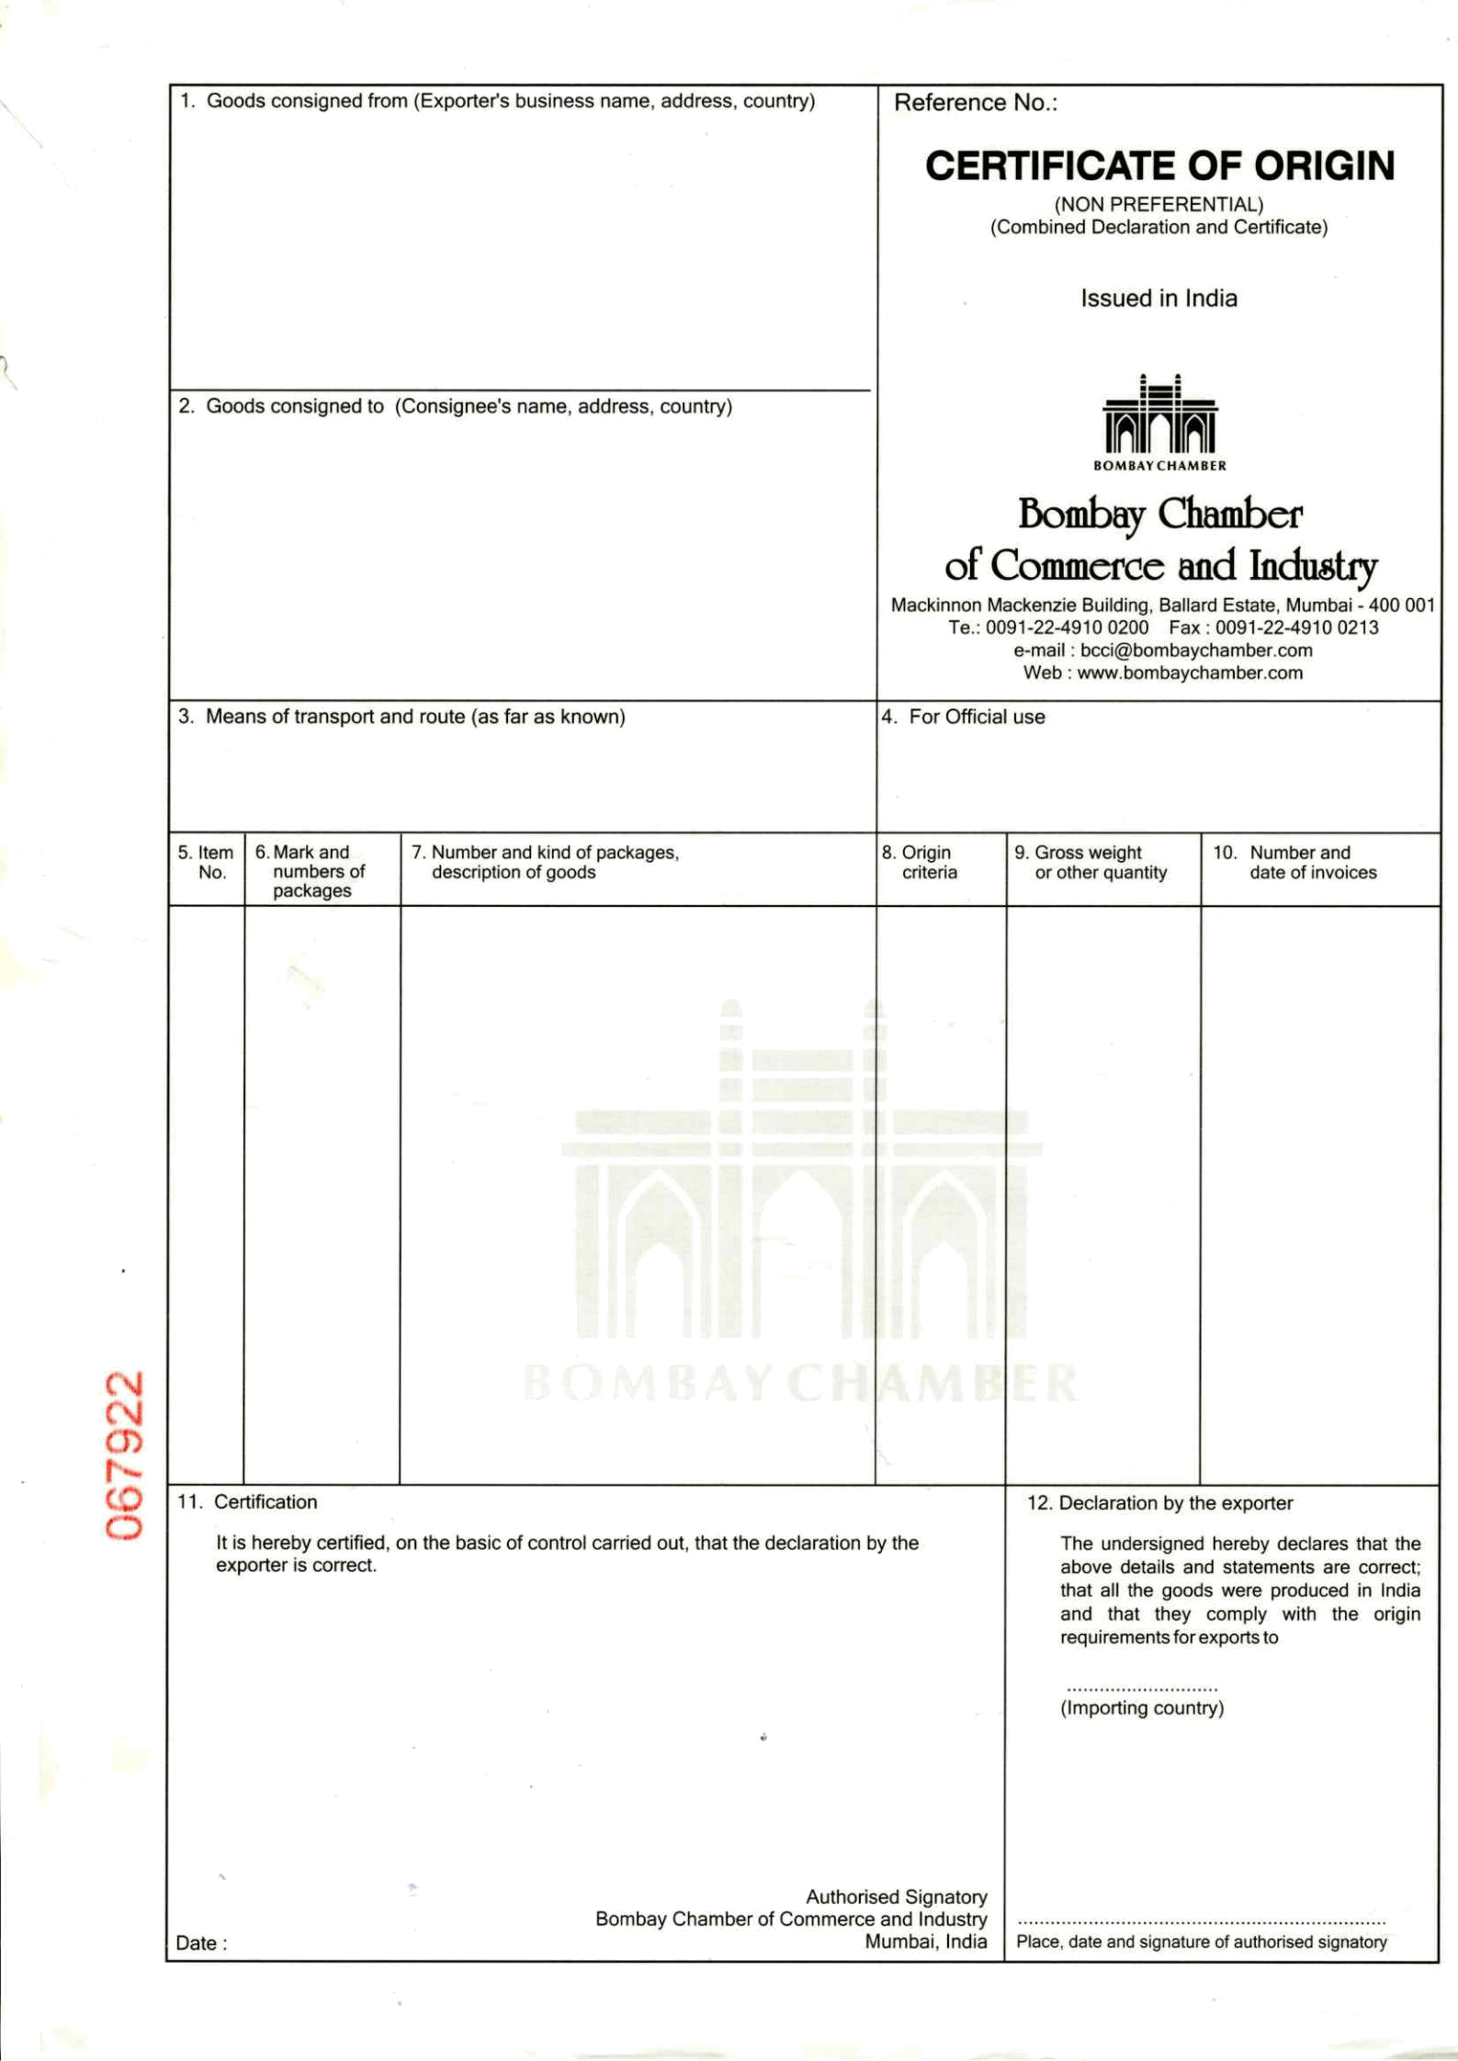
GSTIN - 24AAACI3076P1ZB

DEVA AGRO KIMYA TARIM SAN, VE TIC A.S.
DUMLUPINAR MAH, HALILAGA CAD.NO.9/1
MERKEZ, AFYONKAEAHISAR
TURKEY.
E-mail: berkan.kaya@devaagro.com
TEL: +90 272 212 07 41 FAX: +90 272 214 32 45
CONTACT PERSON : MR, BERKAN KAYA

NHAVA SHEVA , INDIA TO PORT AMBARLI, TURKEY
VESSEL & VOY : MAERSK KIEL , Voyage No - (033W)

COUNTRY 1x20 ft HQ LCL CONTS INDIA GROSS WEIGHT INV.NO. 17 AMBARLI, TURKEY 120 PAPER BAGS ON 03 PALLETS ONLY : 3138.00 KG
120 PAPER BAGS
ORIGIN INSECTICIDES FOR AGRICULTURE PURPOSE NET WEIGHT : Invoice Dtd: INDIA THIOPHANATE METHYL 97% TC : 3000.00 KG 24.07.2020
PAPER BAG.1 -120 (H.S. CODE NO . 3808.92.90)
BATCH NO. D1802 PACKING: 25 KG X 1 PAPER BAGS
Qty : 3000 KG
UN no. : 3077, Class :9 Packing Group :III

“WE CERTIFY THAT
THE GOODS ARE INDIAN ORIGIN.”
CONTAINER NO
MSKU7395839/20DV
CUSTOM SEAL: 2499431

SHIPPING LINE SEAL NO
INV NO.: 17 / 24.07.2020
MLIN3033572 SB NO: 4053597 DATED..25.07.2020
BL NO.NASAML2098878 DATED. 14.08.2020
IEC NO: 0501068023 BRANCH NO. 11

.

TURKEY
DATE: 19.08.2020

